THE FLOYD COLLINS STORY
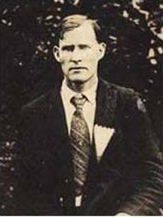
  William Floyd Collins
  July 20, 1887 - February 13, 1925
  Cave explorer and guide, Collins discovered Crystal Cave in 1917. He has been referred to as "The Greatest Cave Explorer Ever Known".
  Searching for another entrance to Mammoth Cave or a new cave, he, explored a hole, later know as Sand Cave. On January 30, 1925 as he was exiting the narrow passageway of the cave he dislodged a rock pinning his leg.
  Trapped 150 feet from the entrance, he was found the next day by Jewell Eaton. After many days of efforts to extricate Collins it was determined it too dangerous to continue and an artificial shaft was begun. When they reached Collins on February 17 he was dead from exposure and starvation.

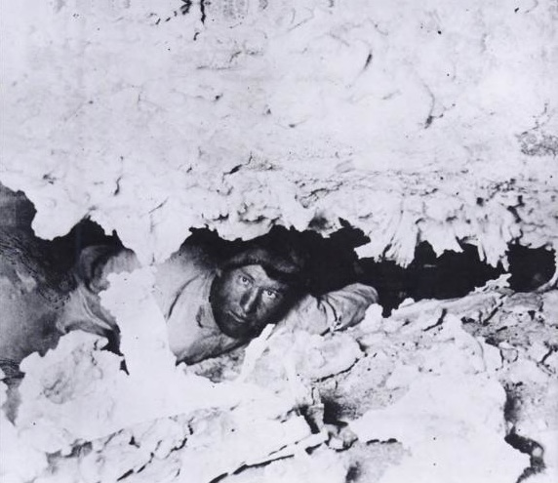
<!--
FLOYD COLLINS HELD PRISIONER IN CAVE SINCE FRIDAY;
CAVE-IN IN SMALL OPENING BLOCKS RESCUERS' WAY
from Glasgow Times, Feb 5, 1925

Cave Prisoner, His Discoverer
  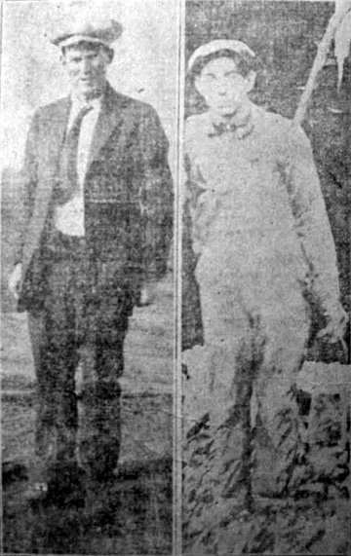
  Floys Collins, age 35, pinioned sinced Friday morning beneath a massive sandstone rock in Sand Cave, four miles south of Cave City, is shwon ot the left of the picture. On the right is Jewell Eaton, 17, who discovered Collins' plight after he had been entombed twenty hours, and who has since worked heroically in effort to save him.
  CAVE-IN IN SMALL OPENING BLOCKS RESCUERS' WAY
  NO IMMEDIATE PROSPECT FOR HIS RELEASE
  Imprisoned Man Has A Heart of Iron And Superb Courage; Is Holding Up In Great Shape And Confident Of Release.
  Latest Bulletin
  At nine p. m., last night Floyd Collins was still trapped in his living tomb in Sand Cave three miles west of Cave City. He was trapped even more securely than any time since Friday, the day he lost his footing and dislodged the sandstone boulder that has tenaciously defied effort to release it.
  There is no possibility of his rescue today, and hope is slight that rescue will be effected tomorrow, if at all. Incessant effort to save him has met with failure since Friday.
  The lives of workers and of Collins, himself were endangered Wednesday by a cave-in, most dreaded of cave catastrophes. It occurred six feet this side of Collins, and cut him off from communications with the outside world. This debris is now being cleared away with acetylene torch, and another attempt along new lines will be made to free him when the passageway is again cleared. The passageway is now electrically lighted and warming pads have been applied to Collins, and a telephone line has been run into the cave for use of the head worker.
  ***
  Collins exploring the hitherto unknown cavern, was making his way out through an eight inch by 10 foot passageway when a large stone became dislodged, pinning his left foot in a crevice. He was unable to move either backward or forward, and was unable to reach rock holding his foot.
  He remained fast until lightly loosened Tuesday night. Food was served him at intervals by his brother, Homer Collins, a very small man, as the opening leading to his head was so small that only a man of slight build could pass through. He was 150 feet from the cave entrance and I the second level.
Every Attempt Fails
Every known means of rescue was tried. A compressed air drill and crew was sent down from Louisville, but fear that the operation of the same would cause a cave-in prevented its use; miners from Western Kentucky were on hand, but they could do no good, as it was impossible to tunnel the opening larger because of danger of falling rock.
Collins’ nerve was superb. Thru the long hours of uncertainty he was cheerful and always held out hope of being rescued. He lay in mud and water, with an ice-cold stream dripping on his face. Some of his rescuers collapsed, but Collins, in dire straits held up bravely. His only complaint was the food in larger quantities was not given him.
One of the most faithful watchers was Lee Collins, 65-year old father of Floyd Collins, imprisoned man. The older Collins, himself a cave explorer for more than forty years, had faith in the rescue of his son.
Variegated Crowd
The crowd gathered about the cave entrance was variegated. It was made up of expert stone-cutters from Louisville, miners from Western Kentucky, Boy Scouts, Salvage Corps men, government engineers, residents of the countryside and others. They stood ankle deep in the mud. Everybody had suggestions to offer, and all were willing to do their part relieving the imprisoned man.
A heaping log fire roared near the cave entrance, and others burned in nearby tents to keep warm the coffee and sandwiches for mud-bespattered volunteers who emerged from the depths for a bite and rest – and then back to their hopeful task.
There was little jesting, for all realized there was tragedy beyond the irregular hole that dipped deep into the bowels of the bluff that frowned overhead.
Story of Imprisonment
The story of Floyd Collins’ imprisonment began Friday with his disappearance. Search was instituted and he was located Saturday in the passageway in Sand Cave on the Doyle farm. Jewell Estes, a mere slip of a boy, wormed his way to him.
Sunday rescue work commenced, with no definite plan of action. All attempts were unsuccessful. Finally outside aid was sought and volunteers poured in from every part of the state to assist in the work.

